**BABYL-RWANDA Backend Assessment-HABIMANA Clement Robert**

1. **Tools Used**
   1. **IDE:** Eclipse IDE
   2. **Programing Language:** Java 8
   3. **Framework:** Spring Boot 2.2, Bootstrap 4( 4on user interface)
   4. **Web Template (for user interface):** Thymeleaf
   5. **API:** REST API
   6. **Other Toosl:** Notepad++, Postman(to test API)
   7. **Git Repository:** GitHub
2. **Part 1. Programming Challenge**
   1. Fizz Buzz Challenge
   2. Pink Flamingo
   3. Roman Numeral convertor
   4. Bodmas Calculator
   5. **Unit Tests(JUnit 4) test coverage**

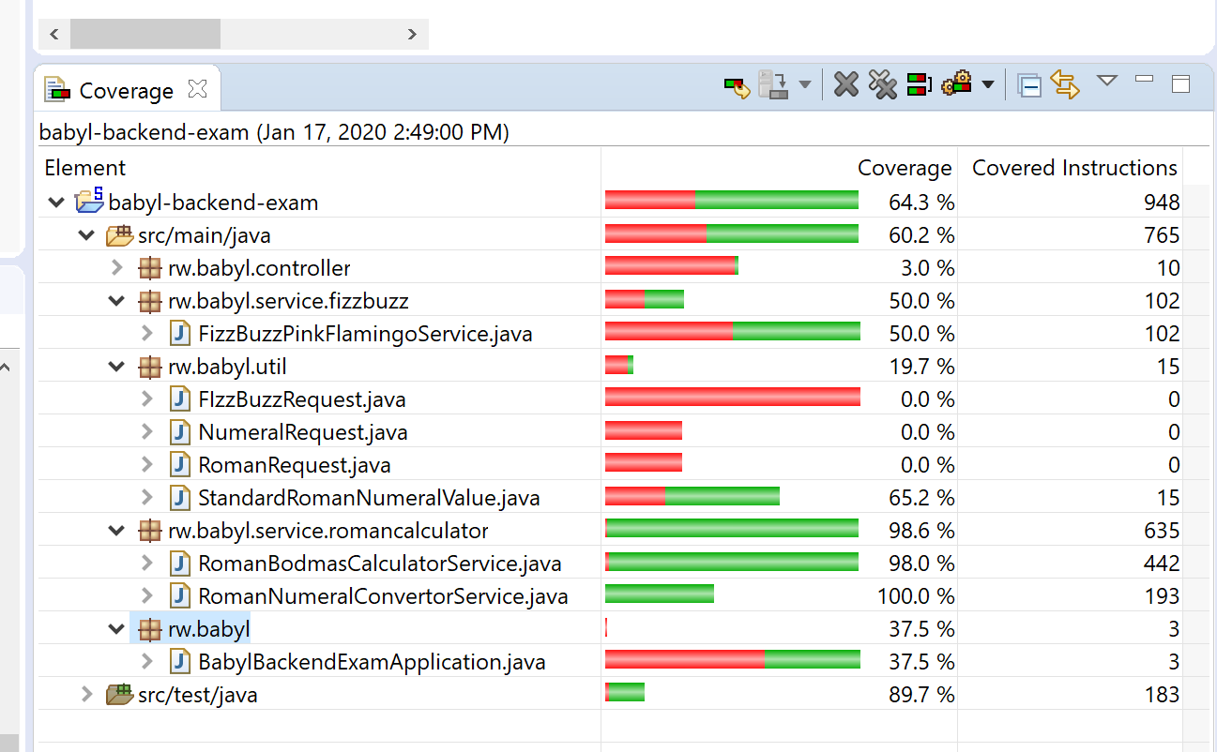

1. **Part-II. API. I chose to expose the first challenge as a REST API**
   1. **localhost:8080/api/fizzbuzz/{minnumber}/{maxNumber}**

[http://localhost:8080//api/fizzbuzz/0/100](http://localhost:8080/api/fizzbuzz/0/100)

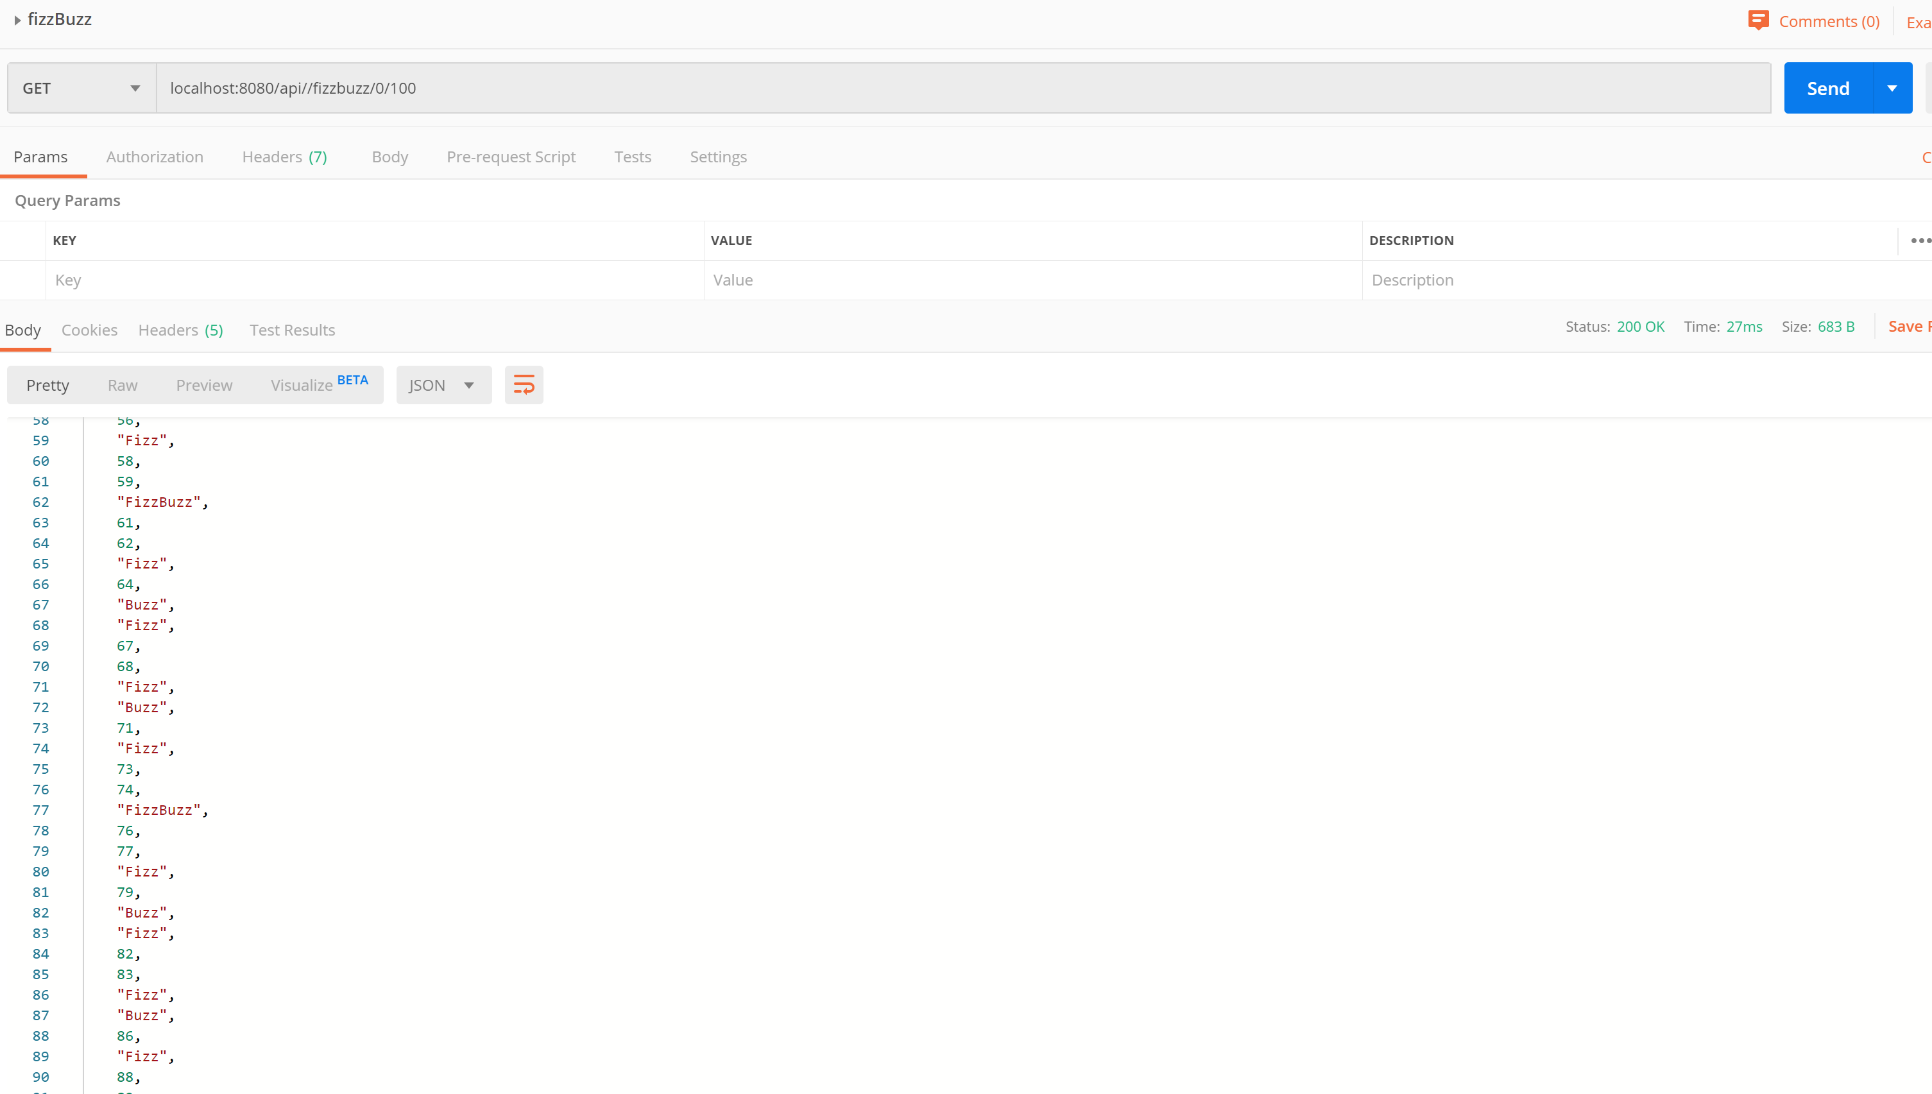

* 1. **localhost:8080/api/flamingo/{minnumber}/{maxNumber}**

[http://localhost:8080//api/flamingo/0/100](http://localhost:8080/api/flamingo/0/100)

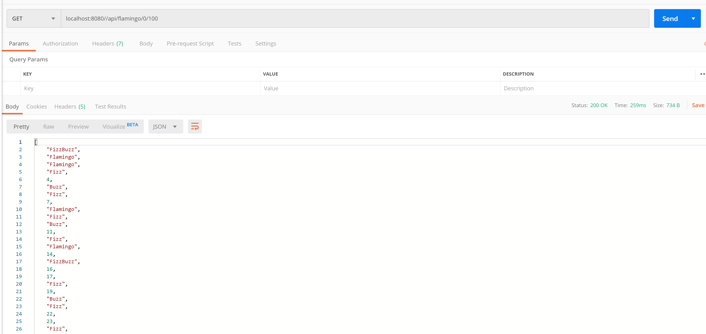

1. **Part-III. User Interface samples**
   1. **Fizz Buzz Challenge :** <http://localhost:8080/fizzbuzz>

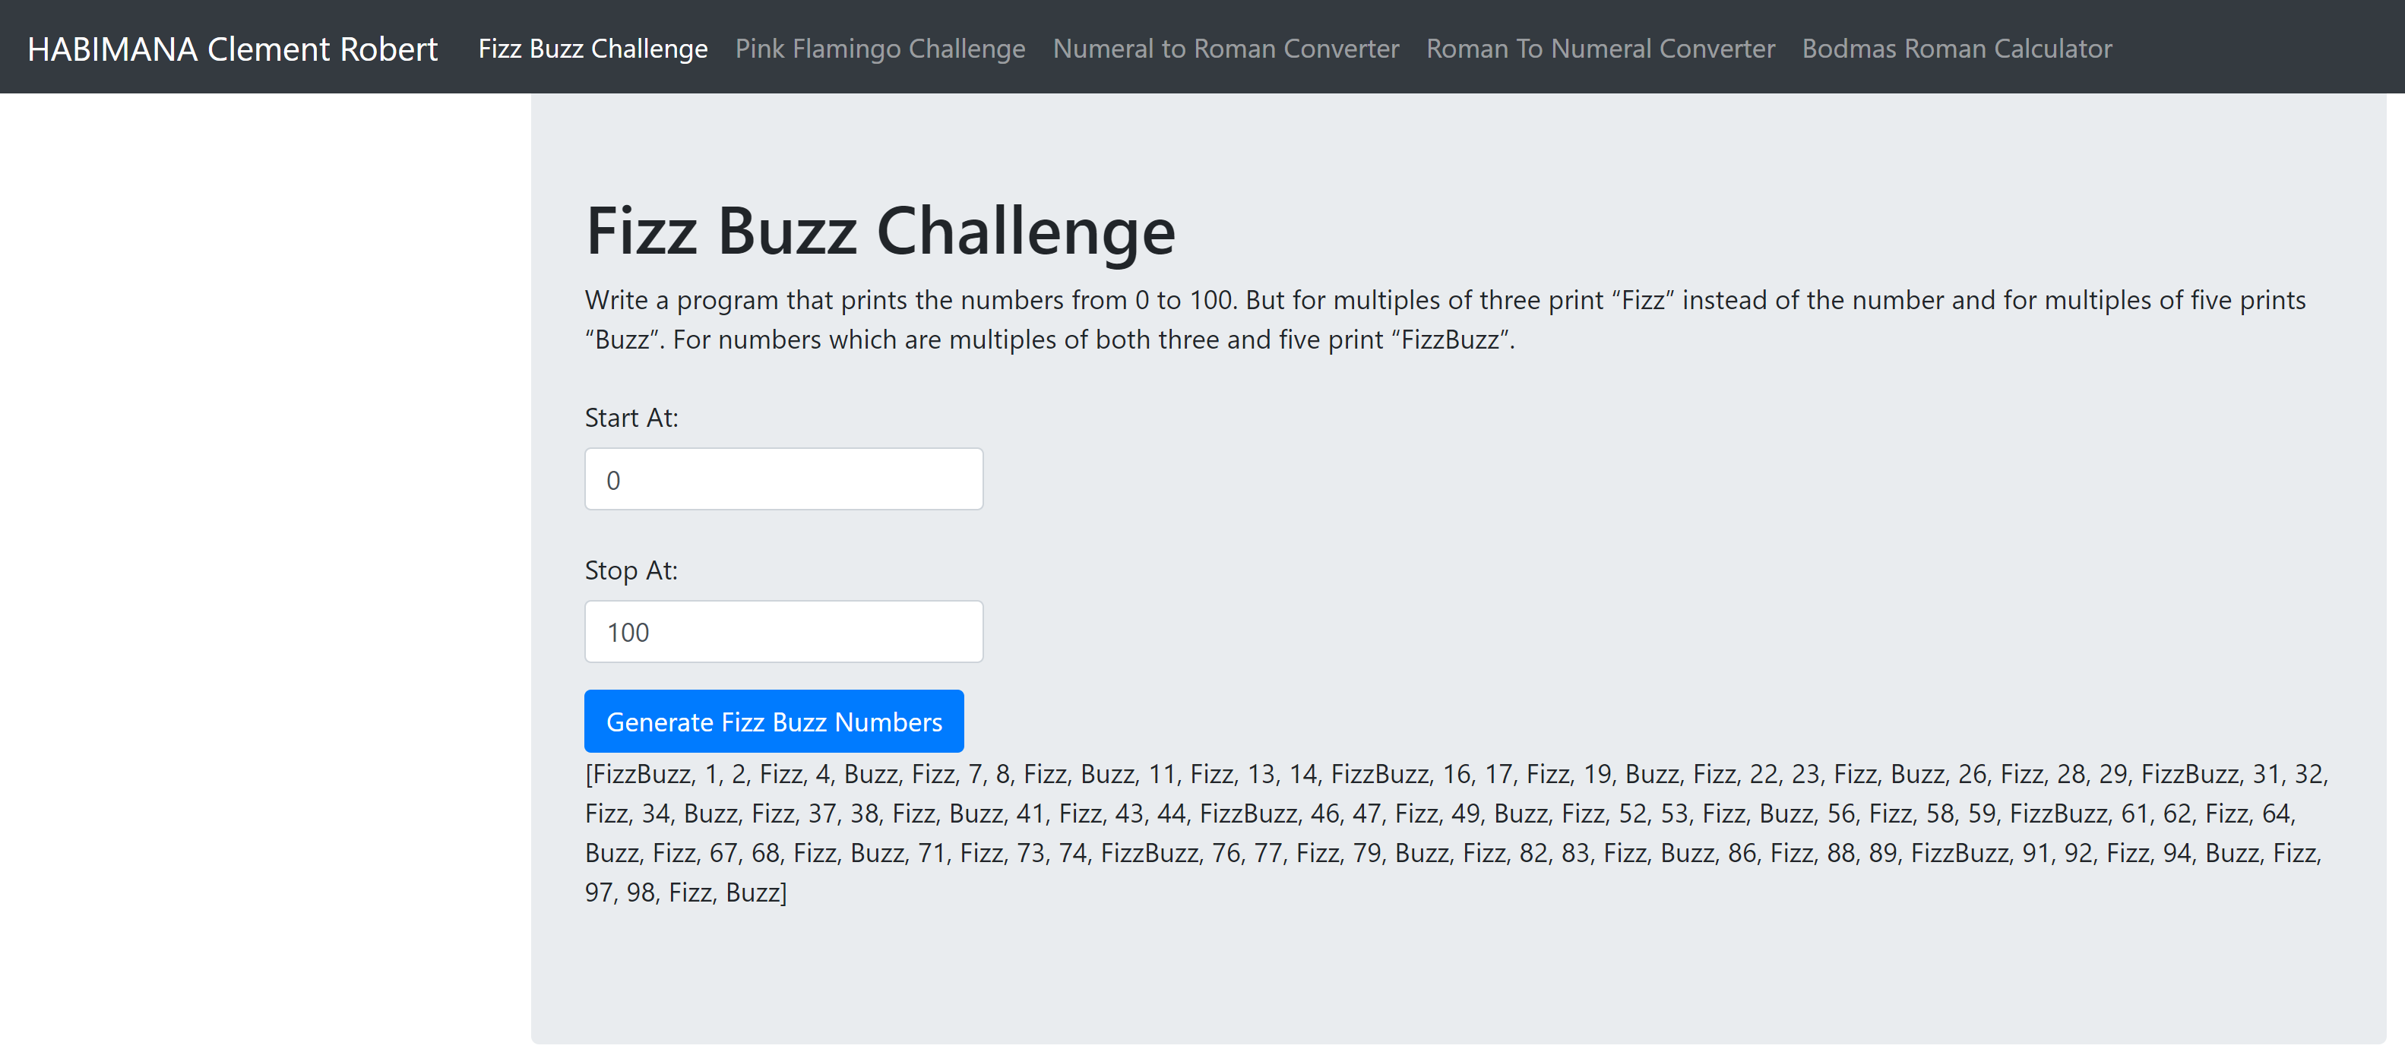

* 1. **Pink Flamingo Challenge:** <http://localhost:8080/flamingo>

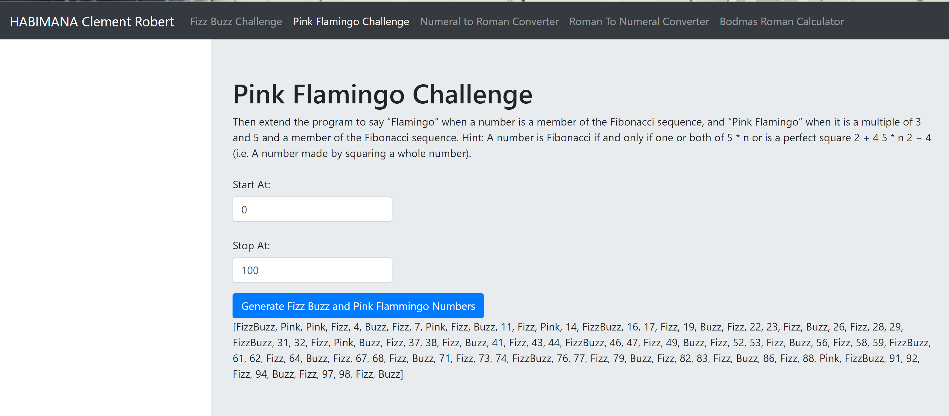

* 1. **Numeral to Roman Converter:** <http://localhost:8080/converter/roman>

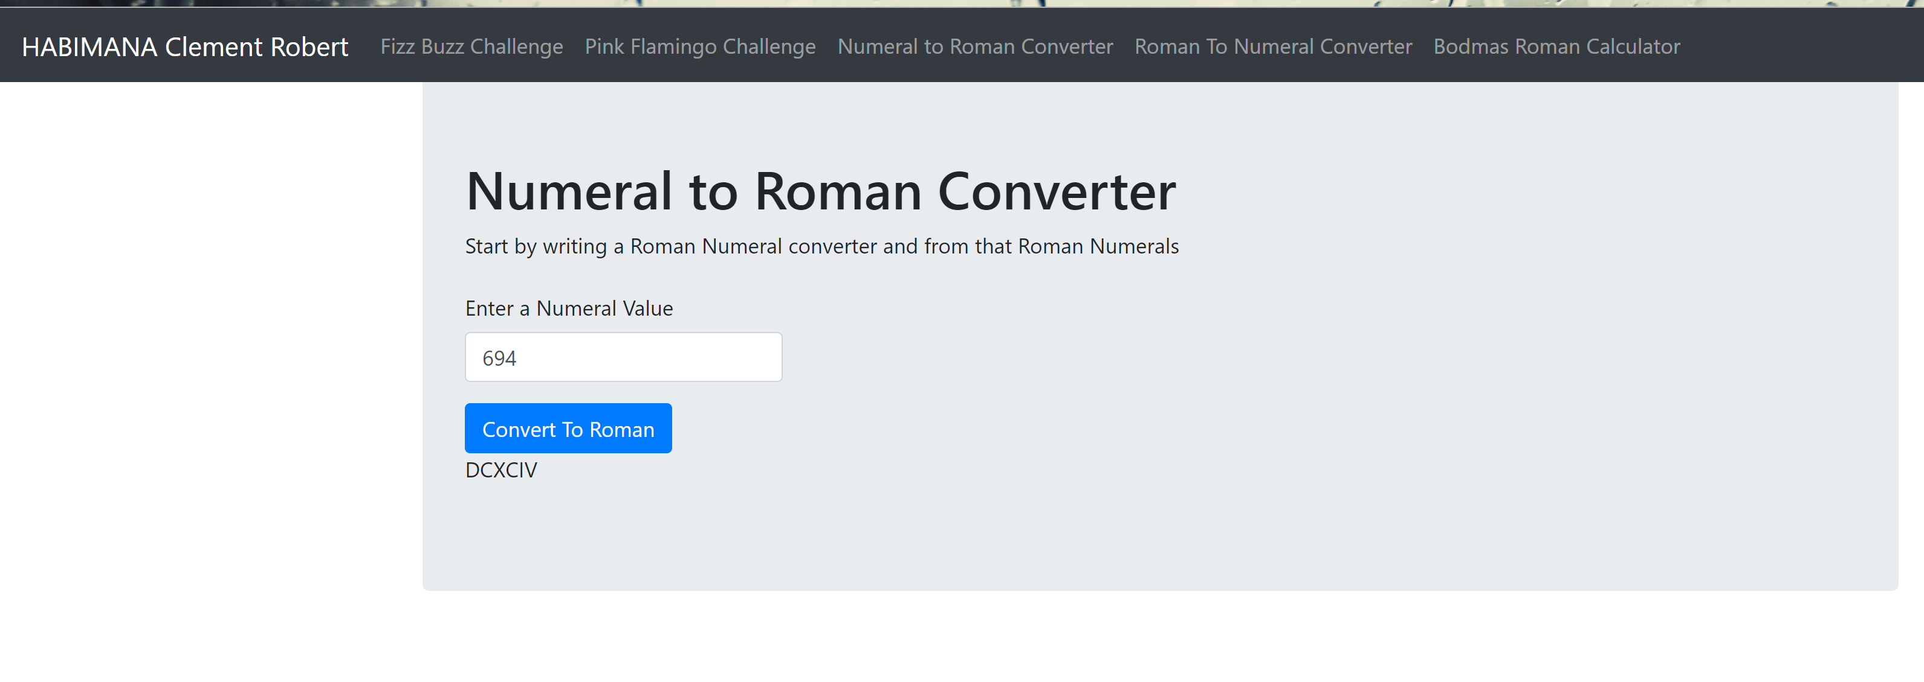

* 1. **Roman to Numeral Converter:** <http://localhost:8080/converter/numeral>

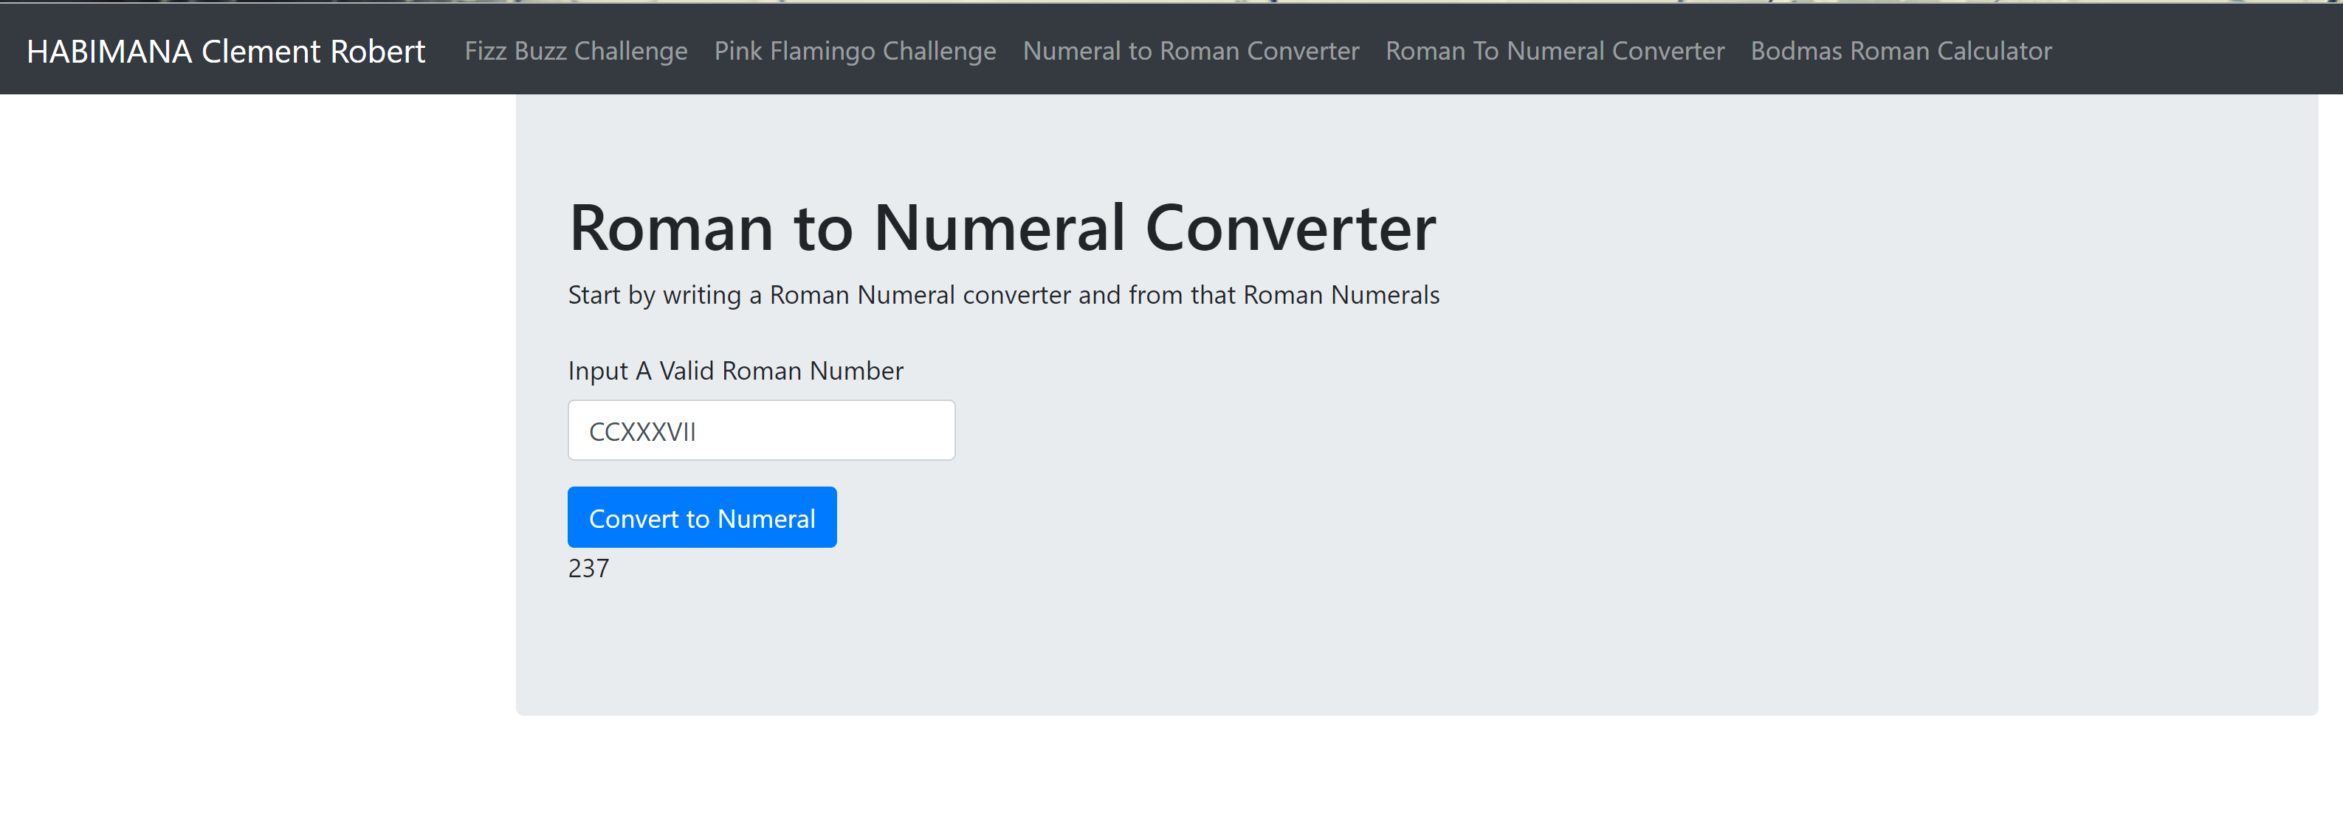

* 1. **Bodmas Roman Calculator:** <http://localhost:8080/bodmas>

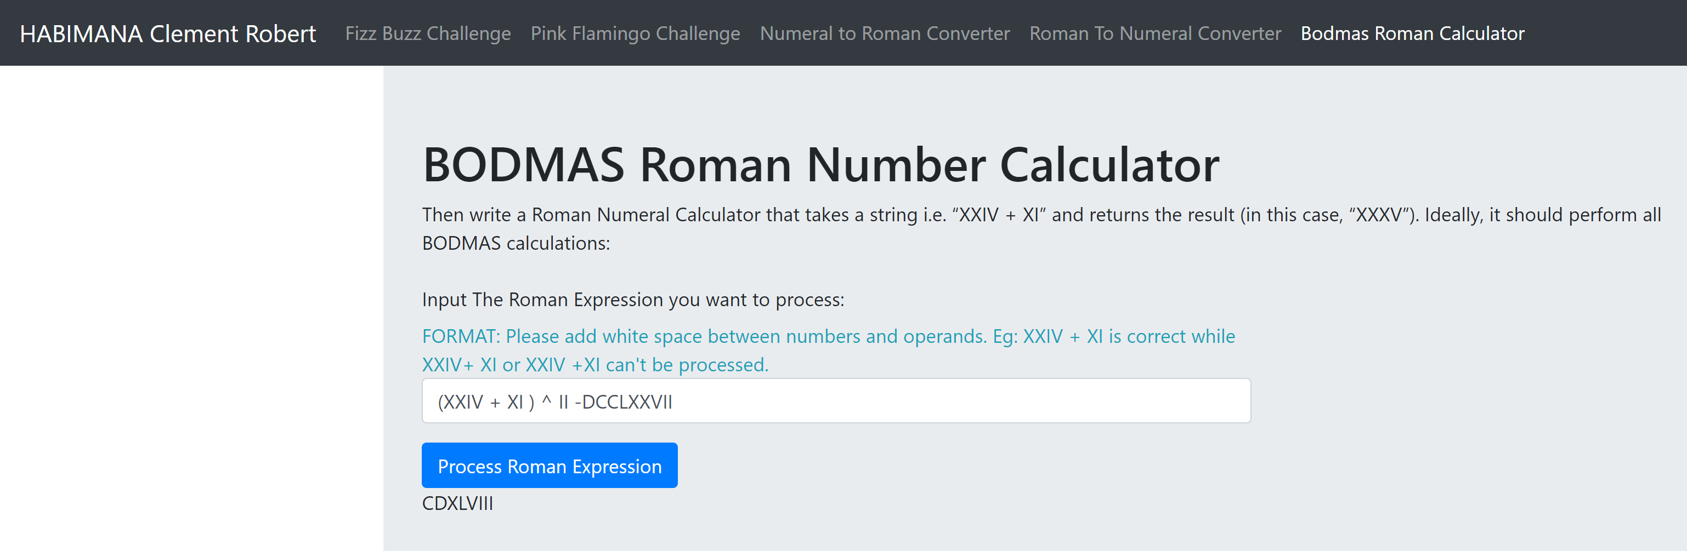

1. **Additional Notes**
   1. **Undergoing work includes:**
      1. Validations and Exceptions
      2. Documentation
      3. General code clean-up